Introduction to Economics (ECON 1580)

University of the People

Instructor Laura Sheneman

Student: Najd Aleid

Learning Journal Unit 2

**Title: Analysis of Equilibrium Price and** Quantity Changes in Supply and Demand Dynamics

**The supply-demand graph is a powerful tool for understanding market dynamics.** By examining the effects of changes in supply and demand on the equilibrium price and quantity, we can gain insights into how markets adjust to different conditions. This analysis will explore four scenarios where either the supply or demand curve shifts independently, explaining the resulting changes in equilibrium price and quantity.

**A) Only supply decreases:**

When the supply decreases, it implies that suppliers are offering a reduced quantity of goods or services at each price level. This reduction in supply causes the supply curve to shift to the left. Let's discuss the effects on equilibrium price and quantity.

**Equilibrium price:**

With a decrease in supply, the supply curve shifts to the left, intersecting the demand curve at a higher price point. As a result, the equilibrium price increases. The higher price motivates suppliers to produce more goods, thereby reducing the gap between the reduced supply and demand (Samuelson & Nordhaus, 2020).

**Equilibrium quantity:**

Due to the decrease in supply, the equilibrium quantity decreases. At the higher equilibrium price, consumers are willing to purchase a smaller quantity of goods or services, leading to a lower quantity demanded. This adjustment in quantity supplied and quantity demanded results in a new equilibrium point with a reduced quantity (Mankiw, 2020).

**B) Only supply increases:**

Conversely, when the supply increases, suppliers offer a greater quantity of goods or services at each price level. This expansion in supply shifts the supply curve to the right. Let's explore the changes in equilibrium price and quantity.

**Equilibrium price:**

With an increase in supply, the supply curve shifts to the right, intersecting the demand curve at a lower price point. Consequently, the equilibrium price decreases. The lower price encourages suppliers to sell the larger quantity of goods they have available (Mankiw, 2020).

**Equilibrium quantity:**

As supply increases, the equilibrium quantity rises. At the lower equilibrium price, consumers are willing to purchase a greater quantity of goods or services. The increased supply can fulfill this higher demand, leading to a new equilibrium point with a higher quantity (Samuelson & Nordhaus, 2020).

**C) Only demand increases:**

When demand increases, consumers exhibit a greater willingness to purchase goods or services at each price level. This shift in demand causes the demand curve to move to the right. Let's discuss the effects on equilibrium price and quantity.

**Equilibrium price:**

With an increase in demand, the demand curve shifts to the right, intersecting the supply curve at a higher price point. As a result, the equilibrium price increases. Suppliers are willing to charge a higher price due to the heightened demand (Mankiw, 2020).

**Equilibrium quantity:**

As demand increases, the equilibrium quantity also increases. At the higher equilibrium price, consumers are willing to purchase a greater quantity of goods or services, resulting in an expansion of the quantity demanded. Suppliers respond to this increased demand by supplying a larger quantity, leading to a new equilibrium point with a higher quantity (Samuelson & Nordhaus, 2020).

**D) Only demand decreases:**

Conversely, when demand decreases, consumers show a reduced willingness to purchase goods or services at each price level. This shift in demand causes the demand curve to move to the left. Let's explore the changes in equilibrium price and quantity.

**Equilibrium price:**

With a decrease in demand, the demand curve shifts to the left, intersecting the supply curve at a lower price point. Consequently, the equilibrium price decreases. Suppliers may need to lower prices to attract buyers given the decreased demand (Mankiw, 2020).

**Equilibrium quantity:**

As demand decreases, the equilibrium quantity also.

**In conclusion, examining the shifts in supply** and demand curves and their impact on equilibrium price and quantity provides valuable insights into the dynamics of market behavior. When the supply curve shifts independently, such as in the case of a decrease in supply, it results in an increase in equilibrium price and a decrease in equilibrium quantity. Conversely, an increase in supply leads to a decrease in equilibrium price and an increase in equilibrium quantity. Similarly, when the demand curve shifts independently, an increase in demand leads to an increase in both equilibrium price and quantity, while a decrease in demand causes a decrease in both equilibrium price and quantity.

**These conclusions align with the findings of** prominent economic textbooks and scholars. Samuelson and Nordhaus (2020) emphasize the interplay between supply, demand, and equilibrium price, shedding light on how changes in supply and demand curves affect market outcomes. Mankiw (2020) further explores the impact of supply and demand changes on equilibrium quantity, providing insights into how market forces respond to fluctuations in supply and demand.

**Understanding the dynamics of equilibrium** price and quantity holds significant importance for businesses, policymakers, and consumers. It enables stakeholders to make informed decisions regarding production levels, pricing strategies, and resource allocation based on an understanding of how changes in supply and demand influence market outcomes.

**In summary, analyzing the changes in equilibrium** price and quantity resulting from shifts in supply and demand dynamics offers valuable insights into market behavior. This knowledge empowers individuals and organizations to navigate the complexities of supply and demand fluctuations and make well-informed decisions.

**Let's consider an example of the market for smartphones to illustrate the changes in equilibrium price and quantity when only the supply decreases.**

**Example: The Impact of Decreased Supply in the Smartphone Market**

**In the market for smartphones, a decrease in supply** could occur due to a shortage of key components, such as microchips, which are essential for smartphone production (Lee, 2021). This shortage leads to a reduction in the quantity of smartphones offered by suppliers at each price level.

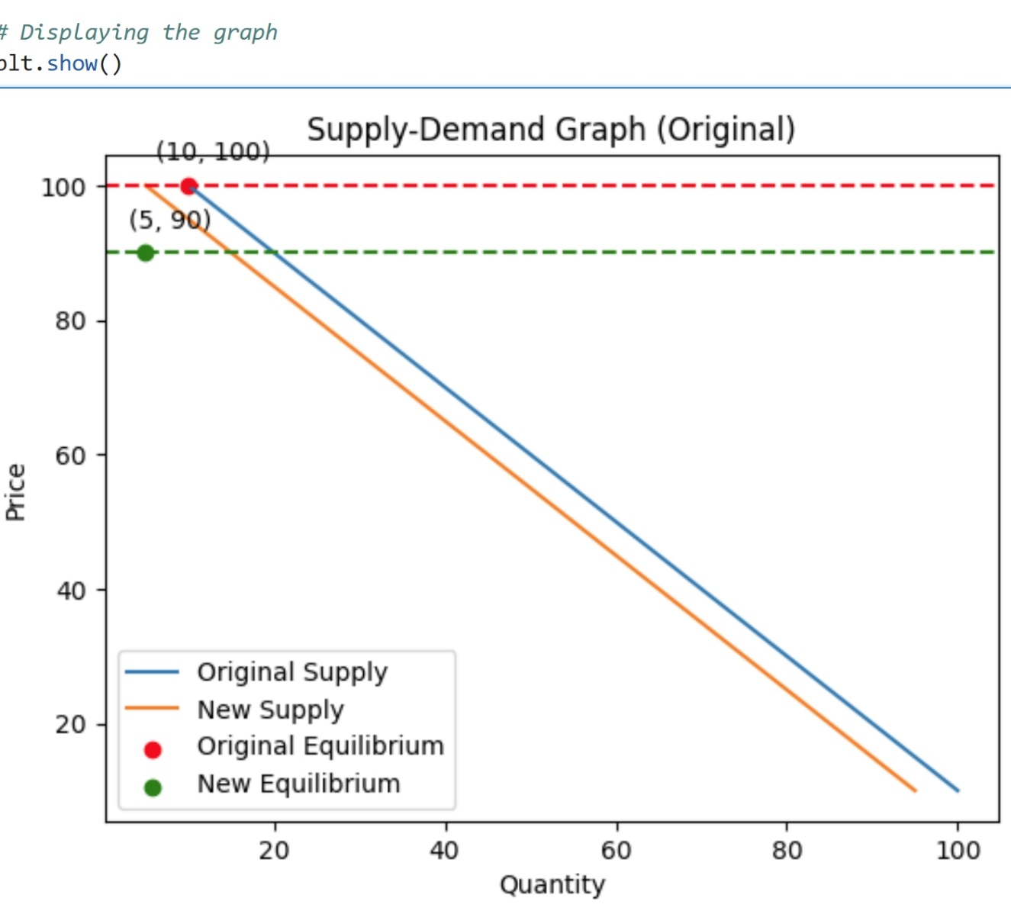



**A supply-demand graph with two supply curves: the** original supply curve and the new supply curve reflecting the decrease in supply. The equilibrium points for both scenarios are indicated by red and green dots, respectively. The equilibrium price lines are drawn as dashed lines, representing the equilibrium prices for the original and new equilibriums.

**By visually inspecting the graph,** you can observe the changes in equilibrium price and quantity. The new equilibrium price is higher, indicating an increase due to the decreased supply. Additionally, the new equilibrium quantity is lower, demonstrating the reduced quantity demanded and supplied.

**Equilibrium price:**

As the supply curve shifts to the left, intersecting the demand curve, the new equilibrium price increases. This occurs because the reduced supply leads to scarcity in the market, and suppliers can charge higher prices to balance the reduced supply and existing demand (Samuelson & Nordhaus, 2020).

**Equilibrium quantity:**

Due to the decrease in supply, the equilibrium quantity decreases. At the higher equilibrium price, consumers are willing to purchase a smaller quantity of smartphones, resulting in a lower quantity demanded. The reduced supply and demand converge at a new equilibrium point with a lower quantity (Mankiw, 2020).

**By examining the example of the** smartphone market, we can observe that when the supply of smartphones decreases, the equilibrium price increases, reflecting the increased scarcity of smartphones. Additionally, the equilibrium quantity decreases, as consumers are willing to purchase a smaller quantity of smartphones at the higher price.

**References**

Lee, J. Y. (2021). Chip shortage could last into 2023, warns major Taiwanese semiconductor firm. The Guardian.

Samuelson, P. A., & Nordhaus, W. D. (2020). Economics. McGraw-Hill Education.

Mankiw, N. G. (2020). Principles of Economics. Cengage Learning.